HEALTHY FOOD AND NUTRITION WEBSITE
HTML and CSS Project

Project Description
This website presents nutritious food categories, healthy recipes, ingredient lists, estimated calorie information, a daily meal plan, and healthy eating tips. It uses responsive cards, navigation links, hover effects, and a mobile-friendly layout.

Website Output Page
Illustrative preview of the website layout. The live page uses the HTML and CSS code included in this document; food photographs load from the image links in the HTML when internet access is available.
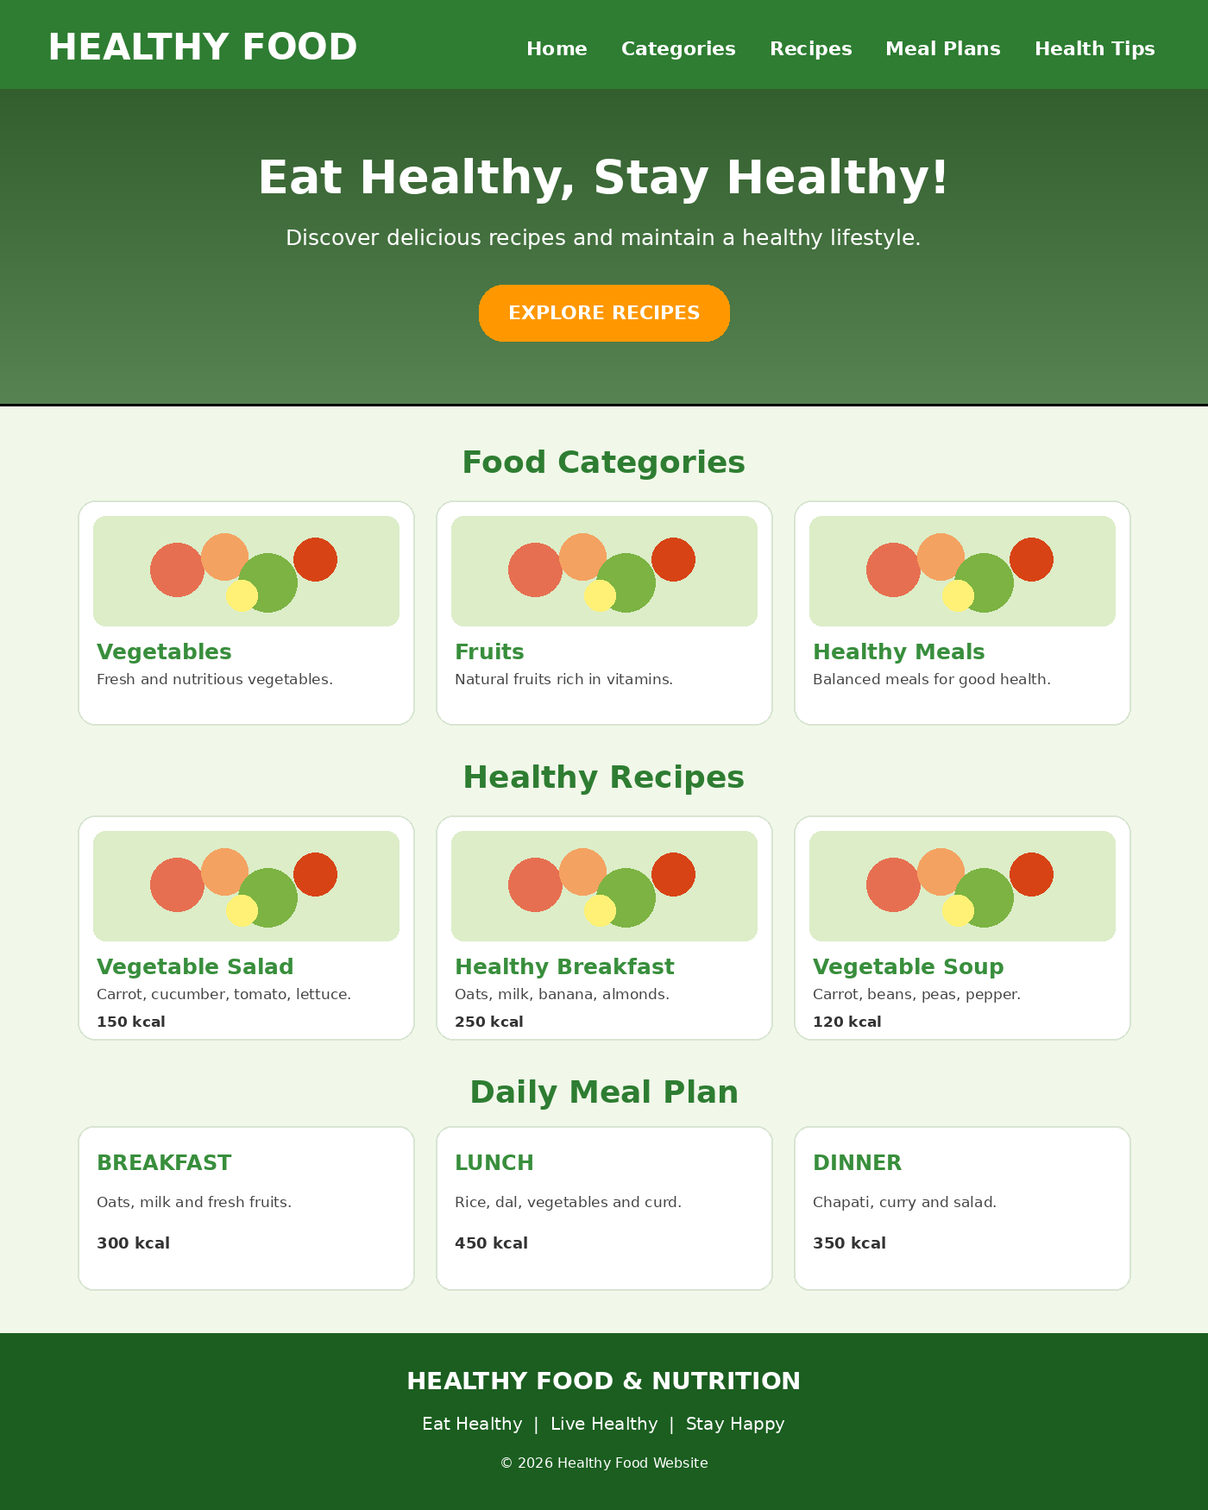

HTML Code (index.html)
<!DOCTYPE html>
<html lang="en">
<head>
<meta charset="UTF-8">
<meta name="viewport" content="width=device-width, initial-scale=1.0">
<title>Healthy Food & Nutrition</title>
<link rel="stylesheet" href="style.css">
</head>
<body>
<header>
<h1>🥗 Healthy Food</h1>
<nav>
<a href="#home">Home</a>
<a href="#categories">Categories</a>
<a href="#recipes">Recipes</a>
<a href="#meal">Meal Plans</a>
<a href="#tips">Health Tips</a>
</nav>
</header>

<section class="hero" id="home">
<h2>Eat Healthy, Stay Healthy!</h2>
<p>Discover delicious recipes and maintain a healthy lifestyle.</p>
<a href="#recipes" class="btn">Explore Recipes</a>
</section>

<section id="categories">
<h2>Food Categories</h2>
<div class="container">
<div class="card">
<img src="https://images.unsplash.com/photo-1512621776951-a57141f2eefd?w=500" alt="Fresh vegetables">
<h3>Vegetables</h3>
<p>Fresh and nutritious vegetables.</p>
</div>
<div class="card">
<img src="https://images.unsplash.com/photo-1490474418585-ba9bad8fd0ea?w=500" alt="Fresh fruits">
<h3>Fruits</h3>
<p>Natural fruits rich in vitamins.</p>
</div>
<div class="card">
<img src="https://images.unsplash.com/photo-1490645935967-10de6ba17061?w=500" alt="Healthy food">
<h3>Healthy Meals</h3>
<p>Balanced meals for good health.</p>
</div>
</div>
</section>

<section id="recipes">
<h2>Healthy Recipes</h2>
<div class="container">
<div class="card">
<img src="https://images.unsplash.com/photo-1512621776951-a57141f2eefd?w=500" alt="Vegetable salad">
<h3>Vegetable Salad</h3>
<p>Ingredients: Carrot, cucumber, tomato, lettuce.</p>
<p><b>Calories:</b> 150 kcal</p>
</div>
<div class="card">
<img src="https://images.unsplash.com/photo-1511690743698-d9d85f2fbf38?w=500" alt="Healthy breakfast">
<h3>Healthy Breakfast</h3>
<p>Ingredients: Oats, milk, banana, almonds.</p>
<p><b>Calories:</b> 250 kcal</p>
</div>
<div class="card">
<img src="https://images.unsplash.com/photo-1547592180-85f173990554?w=500" alt="Vegetable soup">
<h3>Vegetable Soup</h3>
<p>Ingredients: Carrot, beans, peas, pepper.</p>
<p><b>Calories:</b> 120 kcal</p>
</div>
</div>
</section>

<section id="meal">
<h2>Daily Meal Plan</h2>
<div class="container">
<div class="card">
<h3>🌅 Breakfast</h3>
<p>Oats, milk and fresh fruits.</p>
<p><b>Calories:</b> 300 kcal</p>
</div>
<div class="card">
<h3>☀ Lunch</h3>
<p>Rice, dal, vegetables and curd.</p>
<p><b>Calories:</b> 450 kcal</p>
</div>
<div class="card">
<h3>🌙 Dinner</h3>
<p>Chapati, vegetable curry and salad.</p>
<p><b>Calories:</b> 350 kcal</p>
</div>
</div>
</section>

<section id="tips">
<h2>Healthy Eating Tips</h2>
<div class="tips">
<p>🥦 Eat fresh fruits and vegetables daily.</p>
<p>💧 Drink enough water every day.</p>
<p>🥗 Choose balanced and nutritious meals.</p>
<p>🚶 Exercise regularly and stay active.</p>
<p>🍎 Avoid excessive junk food and sugary drinks.</p>
</div>
</section>

<footer>
<h3>Healthy Food & Nutrition</h3>
<p>Eat Healthy | Live Healthy | Stay Happy</p>
<p>© 2026 Healthy Food Website. All Rights Reserved.</p>
</footer>
</body>
</html>

CSS Code (style.css)
* {
margin: 0;
padding: 0;
box-sizing: border-box;
font-family: Arial, sans-serif;
scroll-behavior: smooth;
}

body {
background-color: #f1f8e9;
color: #333;
}

header {
background-color: #2e7d32;
color: white;
padding: 20px;
display: flex;
justify-content: space-between;
align-items: center;
flex-wrap: wrap;
}

header h1 { font-size: 28px; }

nav a {
color: white;
text-decoration: none;
margin: 10px;
font-weight: bold;
}

nav a:hover { color: #ffeb3b; }

.hero {
background: linear-gradient(#0006, #0006),
url("https://images.unsplash.com/photo-1490645935967-10de6ba17061?w=1200");
background-size: cover;
background-position: center;
text-align: center;
color: white;
padding: 110px 20px;
}

.hero h2 { font-size: 40px; margin-bottom: 15px; }
.hero p { font-size: 18px; margin-bottom: 25px; }

.btn {
background-color: #ff9800;
color: white;
padding: 12px 25px;
text-decoration: none;
border-radius: 25px;
}

.btn:hover { background-color: #e65100; }

section { padding: 45px 20px; }

section h2 {
text-align: center;
color: #2e7d32;
margin-bottom: 30px;
font-size: 30px;
}

.container {
display: flex;
justify-content: center;
flex-wrap: wrap;
gap: 25px;
}

.card {
background-color: white;
width: 300px;
padding: 18px;
border-radius: 12px;
text-align: center;
box-shadow: 0 4px 10px #0002;
transition: 0.3s;
}

.card:hover {
transform: translateY(-8px);
box-shadow: 0 8px 18px #0003;
}

.card img {
width: 100%;
height: 190px;
object-fit: cover;
border-radius: 10px;
}

.card h3 { color: #388e3c; margin: 15px 0; }
.card p { margin: 10px 0; line-height: 1.5; }

.tips {
max-width: 700px;
margin: auto;
background-color: white;
padding: 25px;
border-radius: 12px;
box-shadow: 0 4px 10px #0002;
}

.tips p {
padding: 12px;
border-bottom: 1px solid #ddd;
font-size: 17px;
}

footer {
background-color: #1b5e20;
color: white;
text-align: center;
padding: 25px;
}

footer p { margin-top: 10px; }

@media (max-width: 768px) {
header {
flex-direction: column;
gap: 15px;
}
nav { text-align: center; }
nav a {
display: inline-block;
margin: 8px;
}
.hero h2 { font-size: 28px; }
.card {
width: 100%;
max-width: 400px;
}
}

How to Run the Website
- Create a folder named Healthy-Food-Website.
- Save the HTML code in a file named index.html.
- Save the CSS code in a file named style.css in the same folder.
- Open index.html in a web browser such as Google Chrome.
- Ensure you have an internet connection to load the online food photographs.

